Mechanical Overview

Year: _2022_____ Semester: __Spring______ Team: __8___ Project:____Automatic filming vehicle_________________________

Creation Date: ____2/2/2022__________________ Last Modified: 2/4/2022

Author: ____Haiwen Zhang_____________________________ Email: _____zhan3237@purdue.edu________________________

Assignment Evaluation:

|  |  |  |  |  |
| --- | --- | --- | --- | --- |
| **Item** | **Score (0-5)** | **Weight** | **Points** | **Notes** |
| **Assignment-Specific Items** | | | | |
| **Commercial Packaging Analysis 1** |  | x2 |  |  |
| **Commercial Packaging Analysis 2** |  | x2 |  |  |
| **CAD Model Illustrations** |  | x4 |  |  |
| **Project Packaging Specifications** |  | x2 |  |  |
| **PCB Footprint Layout** |  | x2 |  |  |
| **Writing-Specific Items** | | | | |
| **Spelling and Grammar** |  | x2 |  |  |
| **Formatting and Citations** |  | x1 |  |  |
| **Figures and Graphs** |  | x2 |  |  |
| **Technical Writing Style** |  | x3 |  |  |
| **Total Score** |  | | |  |

5: Excellent 4: Good 3: Acceptable 2: Poor 1: Very Poor 0: Not attempted

Comments:

*Comments from the grader will be inserted here.*

1. Commercial Product Packaging

We analyzed two commercial products that are remote controlled filming vehicles. Both of them are very similar to our automatic filming vehicle while processing some differences.. These products are “**DEERC RC Cars DE36W Remote Control Car with 720P HD FPV Camera**” [1] and “**Freefly Tero Remote Controlled Car**” [2].

* 1. Product #1

# **DEERC RC Cars DE36W Remote Control Car with 720P HD FPV Camera:**

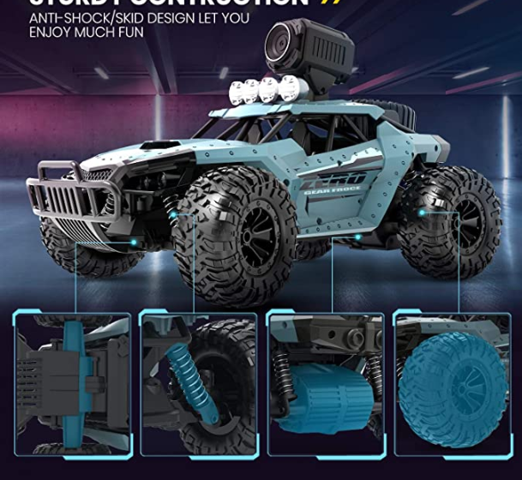

Figure 1: DE36W overall image

The first product we are comparing to has four regular wheels. Compared to the macnum wheels we use on our product, they lack the ability of moving in all directions. However, they implemented shock absorbers on every wheel, thus protecting the chassis structure, increasing the durability of the product. This is something we could incorporate into our product. They have a plastic overall package and a cool design. Our product has mostly metal structures which weigh more but at the same time increase the robustness.

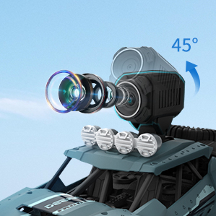

Figure 2: DE36W camera zoom-in image

As for the camera part, it does not have a gimbal associated with the camera compared to our product. They have a 720p camera pre-installed on their product. In contrast, we provide a gimbal on which the user can install their choice of camera. The gimbal will provide a better quality of video. Using the remote controller, the user can control both the yaw and roll angle of the gimbal, capturing 360 degree video without having to move the chassis. The above product’s camera is connected to wifi and the video can be viewed live on a cell phone. For our product, the user can easily install a cell phone on the gimbal and use a streaming application to view the live video even without wifi (using cellular network connection instead).

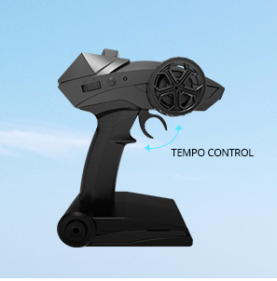

Figure 3: DE36W remote controller image

The remote for the product has a cool design. For our remote controller, there are two joysticks, one for controlling the moving of the vehicle and the other one for controlling the gimbal. What we can learn from their remote controller is their cool design which makes it more interesting to use.

* 1. Product #2

**Freefly Tero Remote Controlled Car:**

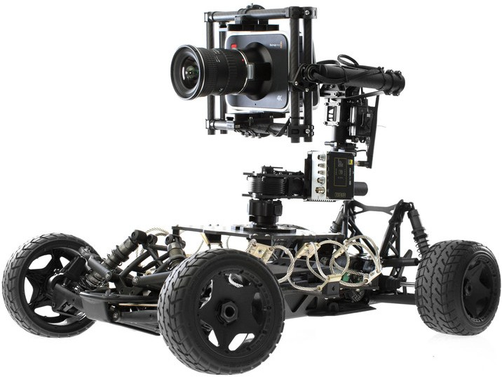

Figure 4: Freefly Tero overall image

This product also has a camera preinstalled on it which prohibits the user to choose cameras on their own. This product has a long thin gimbal arm which is easier to break when handling and especially when transporting. There are wires exposed which are easy to tangle to branches of objects when operating in a complicated environment. They have a 3 axis gimbal while we only have 2 axis gimbal on our product. Like the first product, this product also employs regular wheels which lack the ability to move in all directions. There is a larger radius for turning.

2.0 Project Packaging Description

As shown in the CAD model, our product has four macnum wheels. The chassis has two layers, on top of the bottom layer, it is where all the wires and PCB will be placed. On top of the second layer, a gimbal structure will be found. Both the gimbal structure and the chassis are metal. There will be a 2cm x 3cm OLED display on top of the vehicle that displays the angles of the chassis.

There will be two joysticks and one switch on the remote controller. One joystick is for controlling the movement of the vehicle, another one is for the movement of the gimbal. The switch is for switching between controlling the vehicle and the control of the gimbal.

3.0 Sources Cited

[1] DEERC RC Cars DE36W Remote Control Car with 720P HD FPV Camera. [Online]. Available:

<https://www.amazon.com/DEERC-Remote-Control-Off-Road-Monster/dp/B07VCCL9VC/ref=sr_1_10?crid=WPWNGRYZWUN0&keywords=filming+robot+vehicle&qid=1643856397&sprefix=filming+robot+vehicle%2Caps%2C57&sr=8-10>

[1] Freefly Tero Remote Controlled Car. [Online]. Available:

<https://www.bhphotovideo.com/c/product/1140576-REG/freefly_950_00024_tero_remote_controlled_vehicle.html>

Appendix 1: CAD Model Illustrations

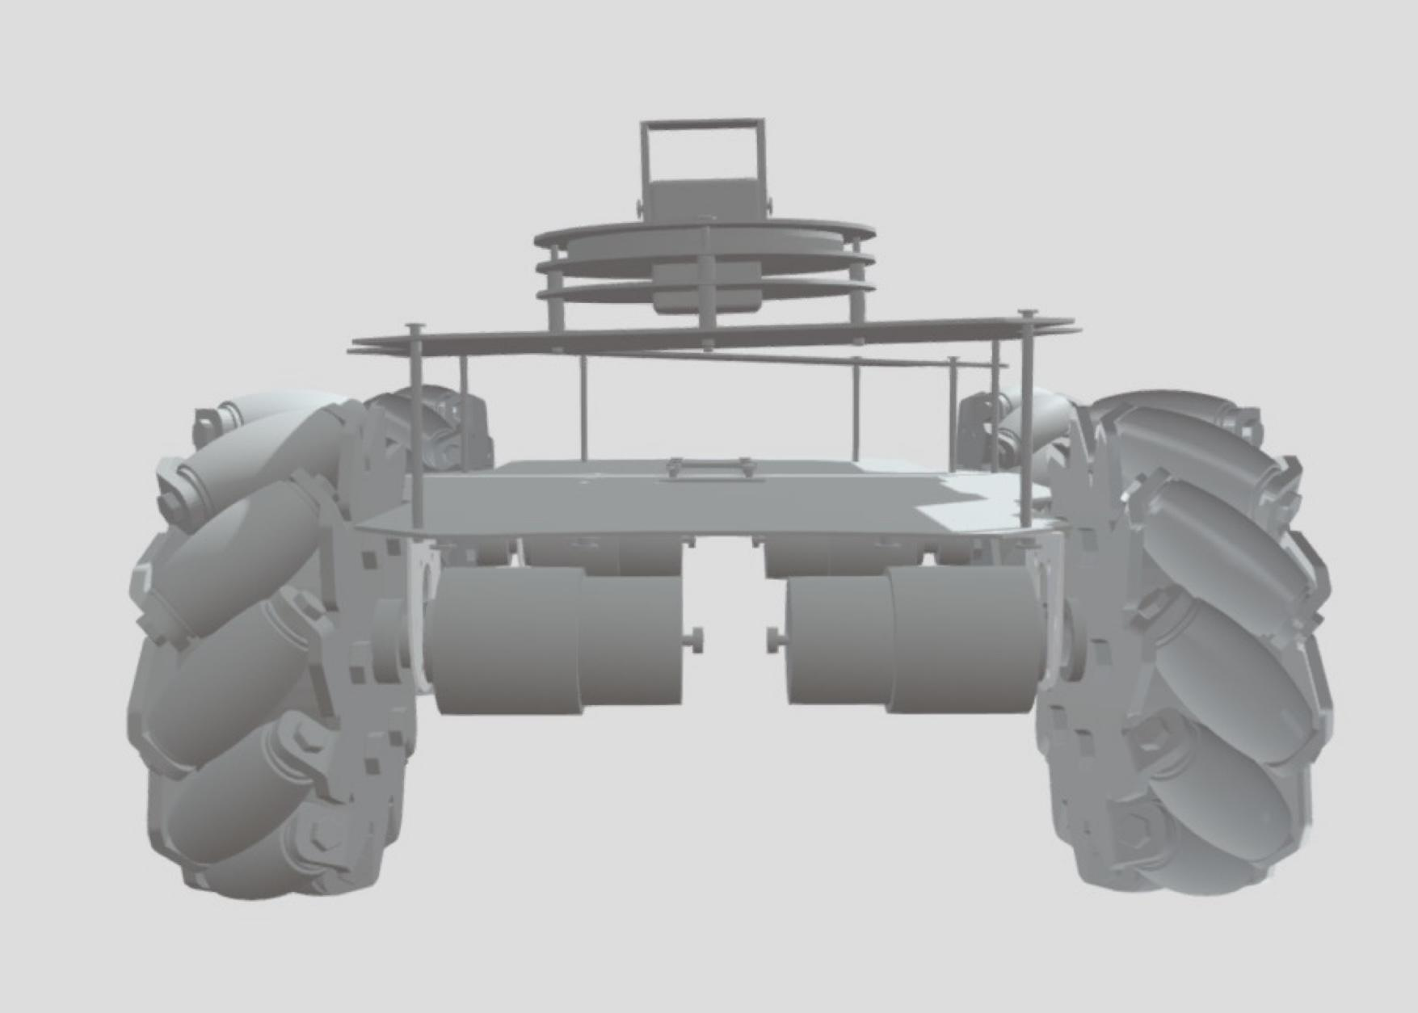

Figure 5: Automatic Filming Vehicle rear view

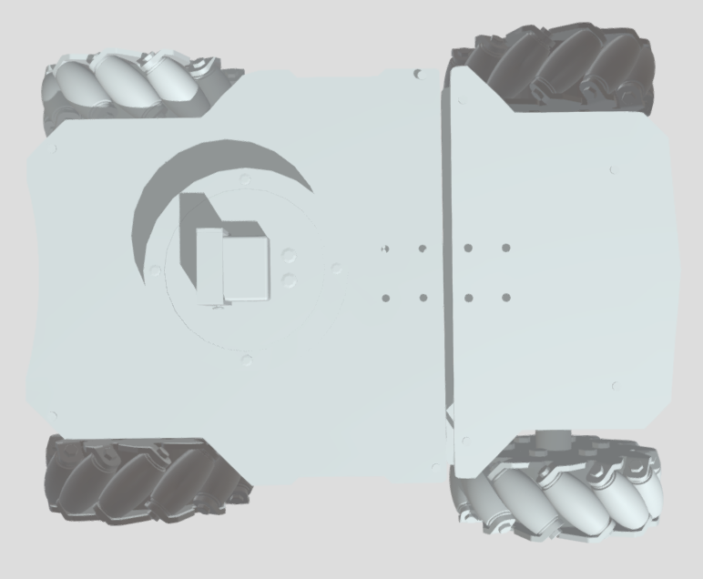

Figure 6: Automatic Filming Vehicle bird’s eye view

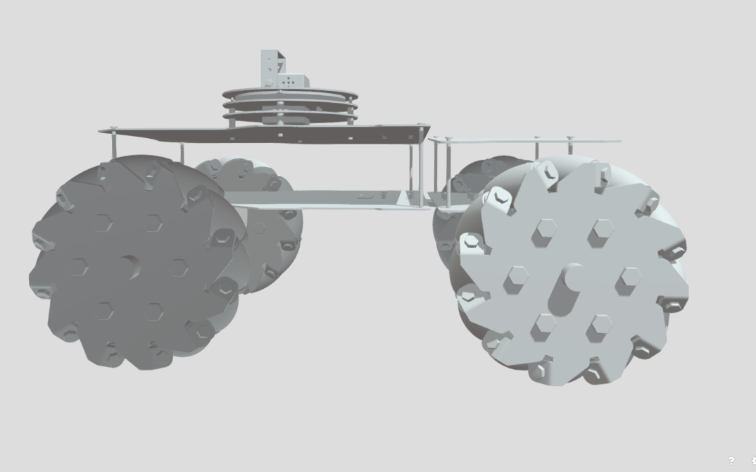

Figure 7: Automatic Filming Vehicle side view

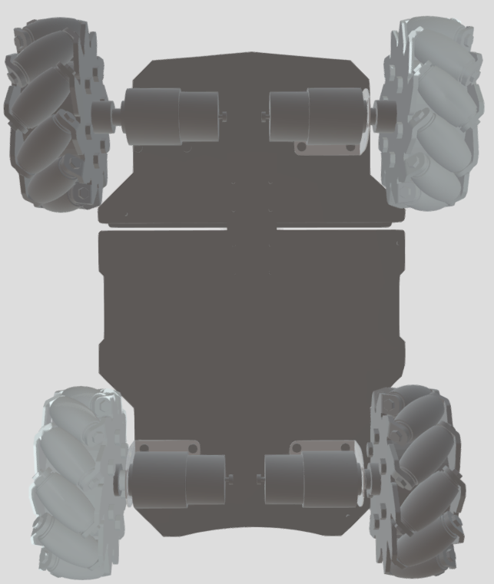

Figure 8: Automatic Filming Vehicle bottom view

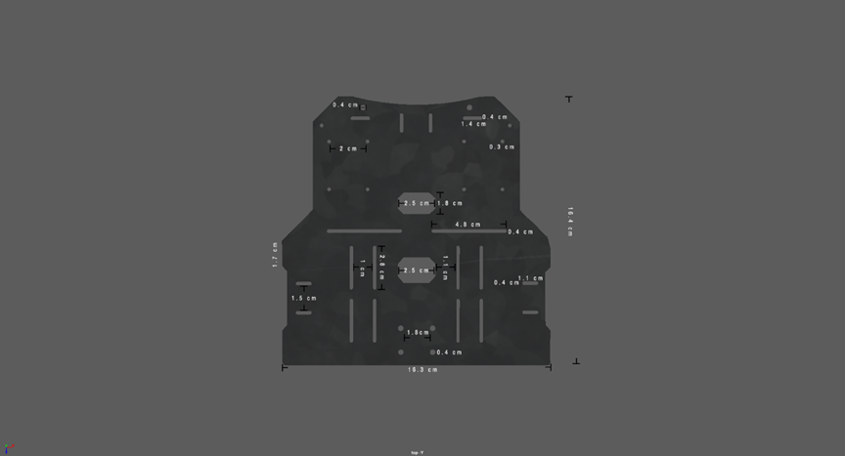

Figure 9: Automatic Filming Vehicle layer dimensions

Dimension: 16.4cm (width) x 16.3cm (length)

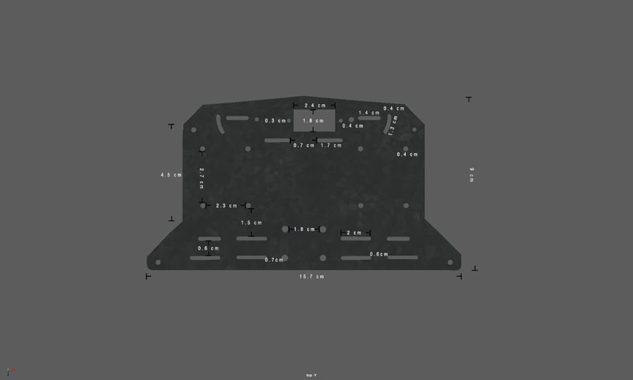

Figure 9: Automatic Filming Vehicle layer dimensions

Dimension: 9cm (width) x 15.7cm (length)

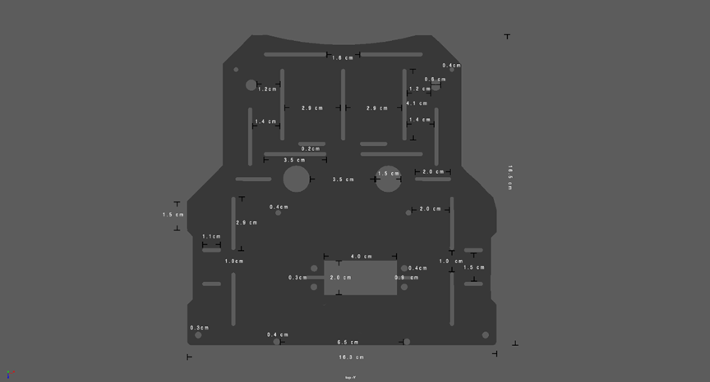

Figure 9: Automatic Filming Vehicle layer dimensions

Dimension: 16.5cm (width) x 16.1cm (length)

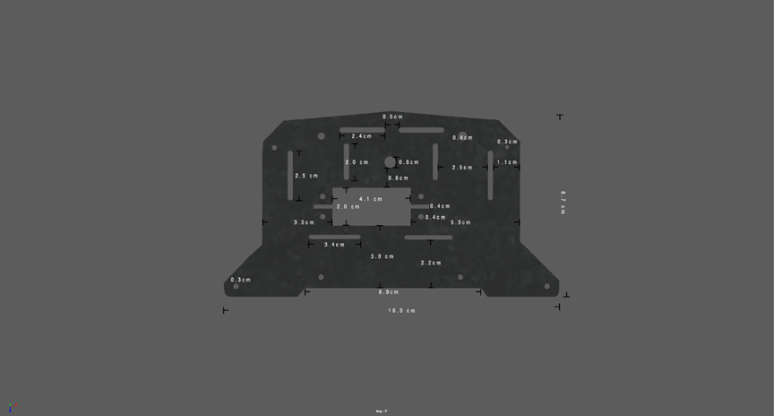

Figure 9: Automatic Filming Vehicle layer dimensions

Dimension: 8.7cm (width) x 16.3cm (length)Appendix 2: Project Packaging Specifications

|  |  |  |  |
| --- | --- | --- | --- |
| Materials | Tools Required | Weight | Cost |
| gimbal structure | screwdriver/screws | 2lb | $30 |
| screws | screwdriver | 0.5lb | $5 |
| macnum wheels | screwdriver/screws | 2lb | $50 |
| vehicle structure | screwdriver | 2lb | $50 |
| remote controller structure | screwdriver/screws | 0.5lb | $20 |
| joysticks | N/A | 0.1lb | $2 |
| PDT switch | N/A | 0.1lb | $2 |
| OLED screen | N/A | 0.1lb | $5 |

Appendix 3: PCB Footprint Layout

**PCB on the vehicle:**

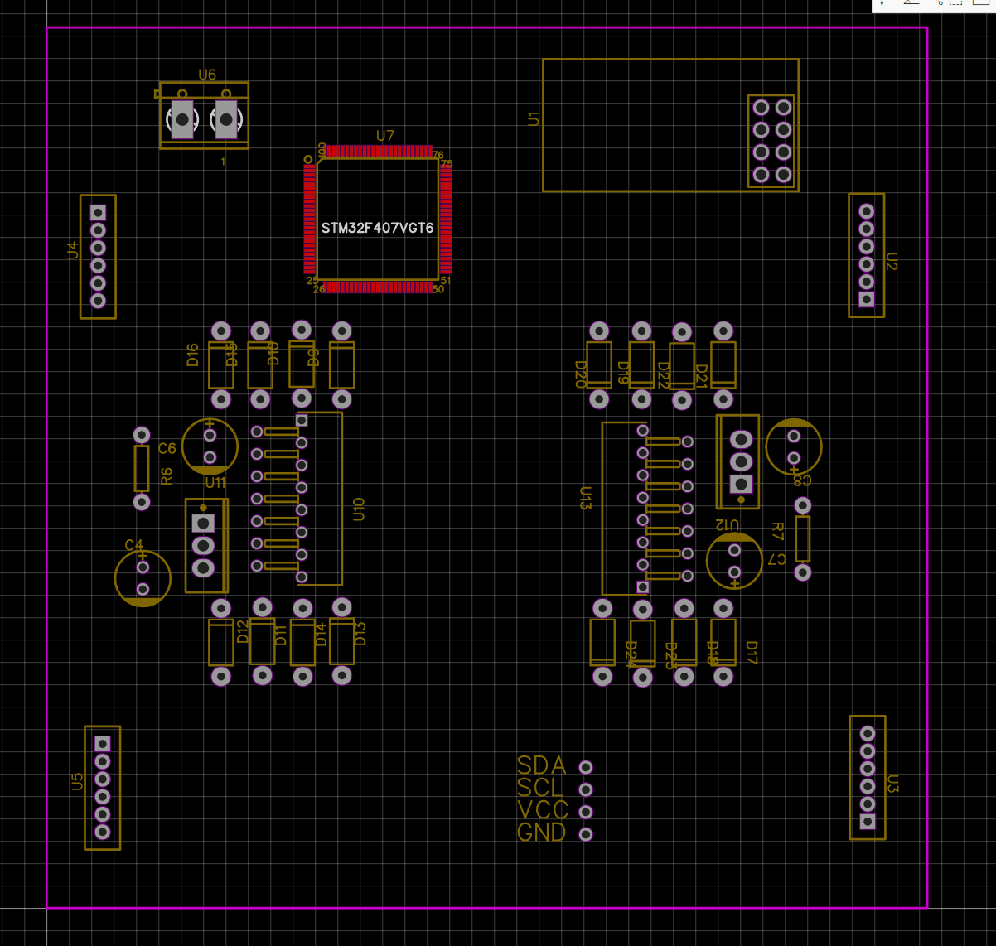

Dimension:

width: ~91 mm

length: ~91 mm

**PCB of remote controller:**

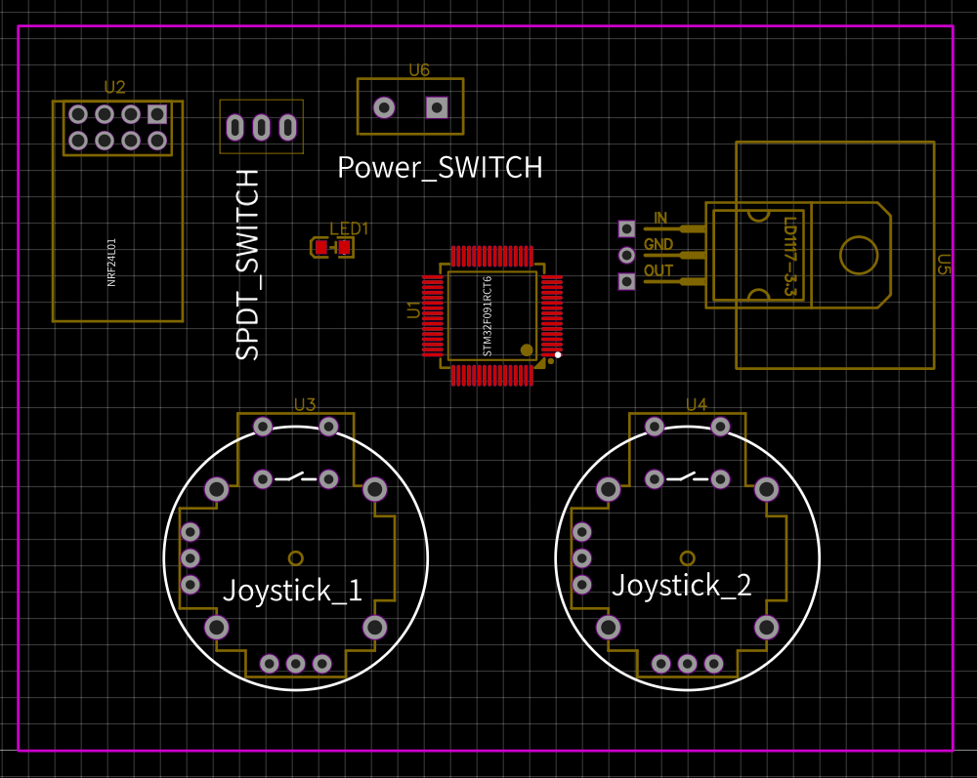

Dimension:

width: ~63 mm

length: ~81 mm